***This is a bonus Web chapter

CHAPTER 39

MVC and Swing Models

Objectives
- To use the model-view-controller approach to separate data and logic from the presentation of data (§39.2).

- To implement the model-view-controller components using the JavaBeans event model (§39.2).

- To explain the Swing model-view-controller architecture (§39.4).
- To use JSpinner to scroll the next and previous values (§39.5).
- To create custom spinner models and editors (§39.6).
- To use JList to select single or multiple items in a list (§39.7).
- To add and remove items using ListModel and DefaultListModel (§39.8).
- To render list cells using a default or custom cell renderer (§39.9).
- To create custom combo box models and renderers (§39.10).
39.1 Introduction
The Swing user interface components are implemented using variations of the MVC architecture. You have used simple Swing components without concern for their supporting models, but in order to use advanced Swing components, you have to use their models to store, access, and modify data. This chapter introduces the MVC architecture and Swing models. Specifically, you will learn how to use the models in JSpinner, JList, and JComboBox. The next chapter will introduce JTable and JTree.

39.2 MVC
<margin note: model>
<margin note: view>
<margin note: controller>
The model-view-controller (MVC) approach is a way of developing components by separating data storage and handling from the visual representation of the data. The component for storing and handling data, known as a model, contains the actual contents of the component. The component for presenting the data, known as a view, handles all essential component behaviors. It is the view that comes to mind when you think of the component. It does all the displaying of the components. The controller is a component that is usually responsible for obtaining data, as shown in Figure 39.1.
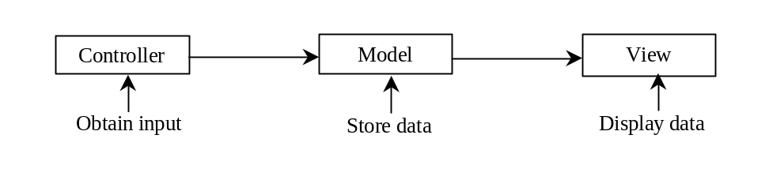

Figure 39.1
The controller obtains data and stores it in a model. The view displays the data stored in the model.

<margin note: MVC benefits>
Separating a component into a model and a view has two major benefits:

- It makes multiple views possible so that data can be shared through the same model. For example, a model storing student names can be displayed simultaneously in a combo box and a list box.
- It simplifies the task of writing complex applications and makes the components scalable and easy to maintain. Changes can be made to the view without affecting the model, and vice versa.
A model contains data, whereas a view makes the data visible. Once a view is associated with a model, it is synchronized with the model. This ensures that all of the model’s views display the same data consistently. To achieve consistency and synchronization with its dependent views, the model should notify the views when there is a change in any of its properties that are used in the view. In response to a change notification, the view is responsible for redisplaying the viewing area affected by the property change.

The Java event delegation model provides a superior architecture for supporting MVC component development. The model can be implemented as a source with appropriate event and event listener registration methods. The view can be implemented as a listener. Thus, if data are changed in the model, the view will be notified. To enable the selection of the model from the view, simply add the model as a property in the view with a set method.

Let us use an example to demonstrate the development of components using the MVC approach. The example creates a model named CircleModel, a view named CircleView, and a controller named CircleControl. CircleModel stores the properties (radius, filled, and color) that describe a circle. filled is a boolean value that indicates whether a circle is filled. CircleView draws a circle according to the properties of the circle. CircleControl enables the user to enter circle properties from a graphical user interface. Create an applet with two buttons named Show Controller and Show View, as shown in Figure 39.2(a). When you click the Show Controller button, the controller is displayed in a frame, as shown in Figure 39.2(b). When you click the Show View button, the view is displayed in a separate frame, as shown in Figure 39.2(c).

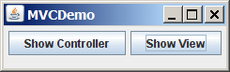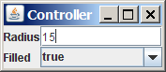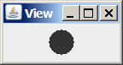
(a) (b) (c)

Figure 39.2
The controller obtains circle properties and stores them in a circle model. The view displays the circle specified by the circle model.

<margin note: date model>
The circle model contains the properties radius, filled, and color, as well as the registration/deregistration methods for action event, as shown in Figure 39.3.

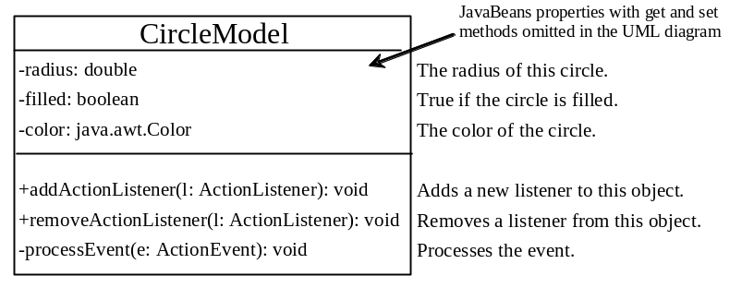

Figure 39.3
The circle model stores the data and notifies the listeners if the data change.

When a property value is changed, the listeners are notified. The complete source code for CircleModel is given in Listing 39.1.

Listing 39.1 CircleModel.java

<margin note line 6: properties>
<margin note line 25: fire event>
<margin note line 37: fire event>
<margin note line 49: fire event>
<margin note line 54: standard code>
<margin note line 62: standard code>
<margin note line 68: standard code>

1 import java.awt.event.*;
2 import java.util.*;
3
4 public class CircleModel {
5 /** Property radius. */
6 private double radius = 20;
7
8 /** Property filled. */
9 private boolean filled;
10
11 /** Property color. */
12 private java.awt.Color color;
13
14 /** Utility field used by event firing mechanism. */
15 private ArrayList<ActionListener> actionListenerList;
16
17 public double getRadius() {
18 return radius;
19 }
20
21 public void setRadius(double radius) {
22 this.radius = radius;
23
24 // Notify the listener for the change on radius
25 processEvent(
26 new ActionEvent(this, ActionEvent.ACTION_PERFORMED, "radius"));
27 }
28
29 public boolean isFilled() {
30 return filled;
31 }
32
33 public void setFilled(boolean filled) {
34 this.filled = filled;
35
36 // Notify the listener for the change on filled
37 processEvent(
38 new ActionEvent(this, ActionEvent.ACTION_PERFORMED, "filled"));
39 }
40
41 public java.awt.Color getColor() {
42 return color;
43 }
44
45 public void setColor(java.awt.Color color) {
46 this.color = color;
47
48 // Notify the listener for the change on color
49 processEvent(
50 new ActionEvent(this, ActionEvent.ACTION_PERFORMED, "color"));
51 }
52
53 /** Register an action event listener */
54 public synchronized void addActionListener(ActionListener l) {
55 if (actionListenerList == null)
56 actionListenerList = new ArrayList<ActionListener>();
57
58 actionListenerList.add(l);
59 }
60
61 /** Remove an action event listener */
62 public synchronized void removeActionListener(ActionListener l) {
63 if (actionListenerList != null && actionListenerList.contains(l))
64 actionListenerList.remove(l);
65 }
66
67 /** Fire TickEvent */
68 private void processEvent(ActionEvent e) {
69 ArrayList<ActionListener> list;
70
71 synchronized (this) {
72 if (actionListenerList == null) return;
73 list = (ArrayList<ActionListener>)(actionListenerList.clone());
74 }
75
76 for (int i = 0; i < list.size(); i++) {
77 ActionListener listener = list.get(i);
78 listener.actionPerformed(e);
79 }
80 }
81 }

NOTE
The registration/deregistration/processEvent methods (lines 54-80) are the same as in lines 49-82 in Listing 27.2, CourseWithActionEvent.java. If you use a GUI builder tool such as NetBeans and Eclipse, the code can be generated automatically.

<margin note: view>
The UML diagram for CircleView is shown in Figure 39.4 and its source code is given in Listing 39.2. The view listens for notifications from the model. It contains the model as its property. When a model is set in the view, a listener is created and registered with the model (lines 13-17). The view extends JPanel and overrides the paintComponent method to draw the circle according to the property values specified in the model.

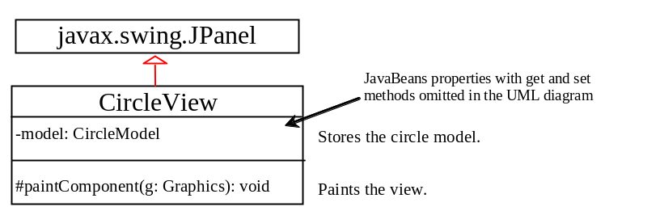

Figure 39.4

The view displays the circle according to the model.

Listing 39.2 CircleView.java

<margin note line 5: model>
<margin note line 8: set model>
<margin note line 26: paint view>

1 import java.awt.*;
2 import java.awt.event.*;
3
4 public class CircleView extends javax.swing.JPanel {
5 private CircleModel model;
6
7 /** Set a model */
8 public void setModel(CircleModel newModel) {
9 model = newModel;
10
11 if (model != null)
12 // Register the view as listener for the model
13 model.addActionListener(new ActionListener() {
14 @Override
15 public void actionPerformed(ActionEvent e) {
16 repaint();
17 }
18 });
19 }
20
21 public CircleModel getModel() {
22 return model;
23 }
24
25 @Override
26 protected void paintComponent(Graphics g) {
27 if (model != null) {
28 super.paintComponent(g);
29 g.setColor(model.getColor());
30
31 int xCenter = getWidth() / 2;
32 int yCenter = getHeight() / 2;
33 int radius = (int)model.getRadius();
34
35 if (model.isFilled()) {
36 g.fillOval(xCenter - radius, yCenter - radius,
37 2 * radius, 2 * radius);
38 }
39 else {
40 g.drawOval(xCenter - radius, yCenter - radius,
41 2 * radius, 2 * radius);
42 }
43 }
44 }
45 }

The controller presents a GUI interface that enables the user to enter circle properties radius and filled. It contains the model as its property. You can use the setModel method to associate a circle model with the controller. It uses a text field to obtain a new radius and a combo box to obtain a boolean value to specify whether the circle is filled. The source code for CircleController is given in Listing 39.3.

Listing 39.3 CircleController.java

<margin note line 6: model>
<margin note line 14: create UI>
<margin note line 47: set model>

1 import java.awt.event.*;
2 import java.awt.*;
3 import javax.swing.*;
4
5 public class CircleController extends JPanel {
6 private CircleModel model;
7 private JTextField jtfRadius = new JTextField();
8 private JComboBox jcboFilled = new JComboBox(new Boolean[]{
9 new Boolean(false), new Boolean(true)});
10
11 /** Creates new form CircleController */
12 public CircleController() {
13 // Panel to group labels
14 JPanel panel1 = new JPanel();
15 panel1.setLayout(new GridLayout(2, 1));
16 panel1.add(new JLabel("Radius"));
17 panel1.add(new JLabel("Filled"));
18
19 // Panel to group text field, combo box, and another panel
20 JPanel panel2 = new JPanel();
21 panel2.setLayout(new GridLayout(2, 1));
22 panel2.add(jtfRadius);
23 panel2.add(jcboFilled);
24
25 setLayout(new BorderLayout());
26 add(panel1, BorderLayout.WEST);
27 add(panel2, BorderLayout.CENTER);
28
29 // Register listeners
30 jtfRadius.addActionListener(new ActionListener() {
31 @Override
32 public void actionPerformed(ActionEvent e) {
33 if (model != null) // Set radius in the model
34 model.setRadius(Double.parseDouble(jtfRadius.getText()));
35 }
36 });
37 jcboFilled.addActionListener(new ActionListener() {
38 @Override
39 public void actionPerformed(ActionEvent e) {
40 if (model != null) // Set filled property value in the model
41 model.setFilled(((Boolean)jcboFilled.getSelectedItem()).
42 booleanValue());
43 }
44 });
45 }
46
47 public void setModel(CircleModel newModel) {
48 model = newModel;
49 }
50
51 public CircleModel getModel() {
52 return model;
53 }
54 }

Finally, let us create an applet named MVCDemo with two buttons, Show Controller and Show View. The Show Controller button displays a controller in a frame, and the Show View button displays a view in a separate frame. The program is shown in Listing 39.4.

Listing 39.4 MVCDemo.java
<margin note line 8: create model>
<margin note line 11: create UI>
<margin note line 20: set model>
<margin note line 33: set model>
<margin note line 41: main method omitted>

1 import java.awt.*;
2 import java.awt.event.*;
3 import javax.swing.*;
4
5 public class MVCDemo extends JApplet {
6 private JButton jbtController = new JButton("Show Controller");
7 private JButton jbtView = new JButton("Show View");
8 private CircleModel model = new CircleModel();
9
10 public MVCDemo() {
11 setLayout(new FlowLayout());
12 add(jbtController);
13 add(jbtView);
14
15 jbtController.addActionListener(new ActionListener() {
16 @Override
17 public void actionPerformed(ActionEvent e) {
18 JFrame frame = new JFrame("Controller");
19 CircleController controller = new CircleController();
20 controller.setModel(model);
21 frame.add(controller);
22 frame.setSize(200, 200);
23 frame.setLocation(200, 200);
24 frame.setVisible(true);
25 }
26 });
27
28 jbtView.addActionListener(new ActionListener() {
29 @Override
30 public void actionPerformed(ActionEvent e) {
31 JFrame frame = new JFrame("View");
32 CircleView view = new CircleView();
33 view.setModel(model);
34 frame.add(view);
35 frame.setSize(500, 200);
36 frame.setLocation(200, 200);
37 frame.setVisible(true);
38 }
39 });
40 }
41 }

The model stores and handles data, and the views are responsible for presenting data. The fundamental issue in the model-view approach is to ensure consistency between the views and the model. Any change in the model should be notified to the dependent views, and all the views should display the same data consistently. The data in the model is changed through the controller.

The methods setRadius, setFilled, and setColor (lines 21, 33, 45) in CircleModel invoke the processEvent method to notify the listeners of any change in the properties.

The setModel method in CircleView sets a new model and registers with a listener for the model by invoking the model's addActionListener method (line 13). When the data in the model are changed, the listener’s actionPerformed method is invoked to repaint the circle (line 15).

The controller CircleController presents a GUI. You can enter the radius from the radius text field. You can specify whether the circle is filled from the combo box that contains two Boolean objects, new Boolean(false) and new Boolean(true) (lines 8-9).

In MVCDemo, every time you click the Show Controller button, a new controller is created (line 18). Every time you click the Show View button, a new view is created (line 30). The controller and view share the same model.

39.3 MVC Variations
A variation of the model-view-controller architecture combines the controller with the view. In this case, a view not only presents the data, but is also used as an interface to interact with the user and accept user input, as shown in Figure 39.5.

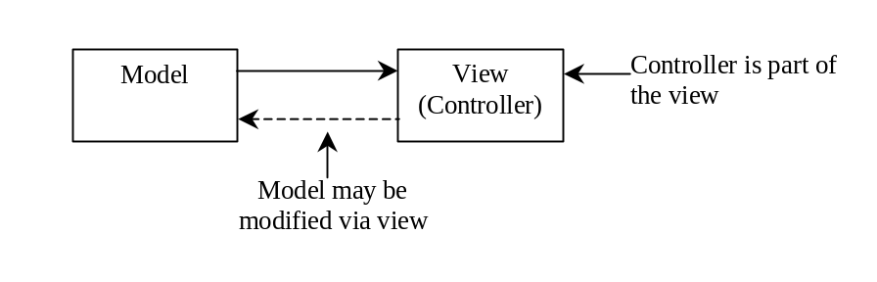

Figure 39.5

The view can interact with the user as well as displaying data.

For example, you can modify the view in the preceding example to enable the user to change the circle’s radius using the mouse. When the left mouse button is clicked, the radius is increased by 5 pixels. When the right mouse button is clicked, the radius is decreased by 5 pixels. The new view, named ViewController, can be implemented by extending CircleView, as follows:

<margin note line 6: mouse listener>
<margin note line 11: left button?>
<margin note line 13: right button?>
1 import java.awt.event.MouseEvent;
2
3 public class ViewController extends CircleView {
4 public ViewController() {
5 // Register mouse listener
6 addMouseListener(new java.awt.event.MouseAdapter() {
7 public void mousePressed(java.awt.event.MouseEvent e) {

8 CircleModel model = getModel(); // Get model
9
10 if (model != null)
11 if (e.getButton() == MouseEvent.BUTTON1)
12 model.setRadius(model.getRadius() + 5); // Left button
13 else if (e.getButton() == MouseEvent.BUTTON3)
14 model.setRadius(model.getRadius() - 5); // Right button
15 }
16 });
17 }
18 }

Another variation of the model-view-controller architecture adds some of the data from the model to the view so that frequently used data can be accessed directly from the view. Swing components are designed using the MVC architecture. Each Swing GUI component is a view that uses a model to store data. A Swing GUI component contains some data in the model, so that it can be accessed directly from the component.

39.4 Swing Model-View-Controller Architecture
Every Swing user interface component (except some containers and dialog boxes, such as JPanel, JSplitPane, JFileChooser, and JColorChooser) has a property named model that refers to its data model. The data model is defined in an interface whose name ends with Model. For example, the model for button component is ButtonModel. Most model interfaces have a default implementation class, commonly named DefaultX, where X is its model interface name. For example, the default implementation class for ButtonModel is DefaultButtonModel. The relationship of a Swing component, its model interface, and its default model implementation class is illustrated in Figure 39.6.

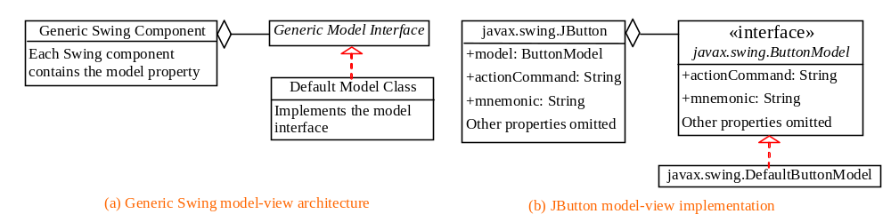Figure 39.6
Swing components are implemented using the MVC architecture.
For convenience, most Swing components contain some properties of their models, and these properties can be accessed and modified directly from the component without the existence of the model being known. For example, the properties actionCommand and mnemonic are defined in both ButtonModel and JButton. Actually, these properties are in the AbstractButton class. Since JButton is a subclass of AbstractButton, it inherits all the properties from AbstractButton.

When you create a Swing component without specifying a model, a default data model is assigned to the model property. For example, lines 9-10 in the following code set the actionCommand and mnemonic properties of a button through its model.

<margin note line 6: get model>
<margin note line 9: set model properties>

1 public class TestSwingModel1 {
2 public static void main(String[] args) {
3 javax.swing.JButton jbt = new javax.swing.JButton();
4
5 // Obtain the default model from the component
6 javax.swing.ButtonModel model = jbt.getModel();
7
8 // Set properties in the model
9 model.setActionCommand("OK");
10 model.setMnemonic('O');
11
12 // Display the property values from the component

13 System.out.println("actionCommand is " + jbt.getActionCommand());

14 System.out.println("mnemonic is " + (char)(jbt.getMnemonic()));
15 }
16 }

<Output>
actionCommand is OK
mnemonic is O

<End Output>

You can also create a new model and assign it to a Swing component. For example, the following code creates an instance of ButtonModel (line 7) and assigns it to an instance of JButton (line 14).

<margin note line 7: create model>
<margin note line 10: set model properties>
<margin note line 14: set a new model>

1 public class TestSwingModel2 {
2 public static void main(String[] args) {
3 javax.swing.JButton jbt = new javax.swing.JButton();
4
5 // Create a new button model
6 javax.swing.ButtonModel model =
7 new javax.swing.DefaultButtonModel();
8
9 // Set properties in the model
10 model.setActionCommand("Cancel");
11 model.setMnemonic('C');
12
13 // Assign the model to the button
14 jbt.setModel(model);
15
16 // Display the property values from the component

17 System.out.println("actionCommand is " + jbt.getActionCommand());

18 System.out.println("mnemonic is " + (char)jbt.getMnemonic());
19 }
20 }
<Output>
actionCommand is Cancel
mnemonic is C

<End Output>

It is unnecessary to use the models for simple Swing components, such as JButton, JToggleButton, JCheckBox, JRadioButton, JTextField, and JTextArea, because the frequently used properties in the models of these Swing components are also the properties in these components. You can access and modify these properties directly through the components. For advanced components, such as JSpinner, JList, JComboBox, JTable, and JTree, you have to work with their models to store, access, and modify data.

39.5 JSpinner
A spinner is a text field with a pair of tiny arrow buttons on its right side that enable the user to select numbers, dates, or values from an ordered sequence, as shown in Figure 39.7. The keyboard up/down arrow keys also cycle through the elements. The user may also be allowed to type a (legal) value directly into the spinner. A spinner is similar to a combo box but is sometimes preferred because it doesn't require a drop-down list that can obscure important data.

Spinner
Spinner

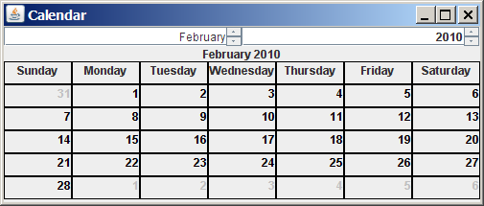

Figure 39.7
Two JSpinner components enable the user to select a month and a year for the calendar.
Figure 39.8 shows the constructors and commonly used methods in JSpinner. A JSpinner's sequence value is defined by the SpinnerModel interface, which manages a potentially unbounded sequence of elements. The model doesn't support indexed random access to sequence elements. Only three sequence elements are accessible at a time—current, next, and previous—using the methods getValue(), getNextValue(), and getPreviousValue(), respectively. The current sequence element can be modified using the setValue method. When the current value in a spinner is changed, the model invokes the stateChanged(javax.swing.event.ChangeEvent e) method of the registered listeners. The listeners must implement javax.swing.event.ChangeListener. All these methods in SpinnerModel are also defined in JSpinner for convenience, so you can access the data in the model from JSpinner directly.

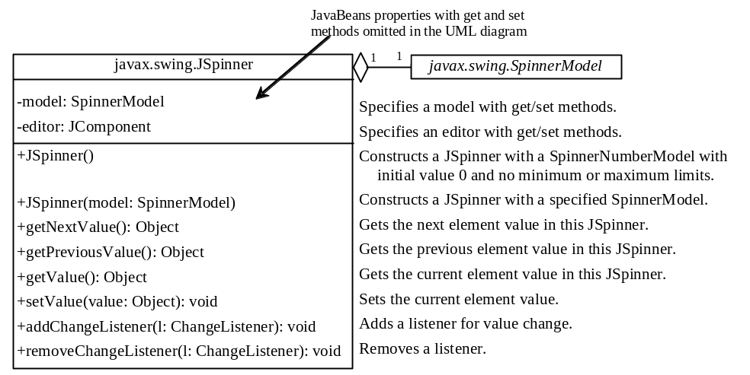

Figure 39.8
JSpinner uses a spinner model to store data.
NOTE: If you create a JSpinner object without specifying a model, the spinner displays a sequence of integers.
Listing 39.5 gives an example that creates a JSpinner object for a sequence of numbers and displays the previous, current, and next numbers from the spinner on a label, as shown in Figure 39.9.

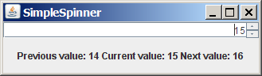

Figure 39.9
The previous, current, and next values in the spinner are displayed on the label.

Listing 39.5 SimpleSpinner.java
<margin note line 7: spinner>
<margin note line 18: spinner listener>
<margin note line 27: main method omitted>

1 import javax.swing.*;
2 import javax.swing.event.*;
3 import java.awt.BorderLayout;
4
5 public class SimpleSpinner extends JApplet {
6 // Create a JSpinner
7 private JSpinner spinner = new JSpinner();
8
9 // Create a JLabel
10 private JLabel label = new JLabel("", JLabel.CENTER);
11
12 public SimpleSpinner() {
13 // Add spinner and label to the UI
14 add(spinner, BorderLayout.NORTH);
15 add(label, BorderLayout.CENTER);
16
17 // Register and create a listener
- spinner.addChangeListener(new ChangeListener() {
- @Override
20 public void stateChanged(javax.swing.event.ChangeEvent e) {
21 label.setText("Previous value: " + spinner.getPreviousValue()
22 + " Current value: " + spinner.getValue()
23 + " Next value: " + spinner.getNextValue());
24 }
25 });
26 }
27 }

A JSpinner object is created using its no-arg constructor (line 7). By default, a spinner displays a sequence of integers.

An anonymous inner class event adapter is created to process the value change event on the spinner (lines 18-25). The previous, current, and next values in a spinner can be obtained using the JSpinner’s instance methods getPreviousValue(), getValue(), and getNextValue().

To display a sequence of values other than integers, you have to use spinner models.

39.6 Spinner Models and Editors
SpinnerModel is an interface for all spinner models. AbstractSpinnerModel is a convenient abstract class that implements SpinnerModel and provides the implementation for its registration/deregistration methods. SpinnerListModel, SpinnerNumberModel, and SpinnerDateModel are concrete implementations of SpinnerModel. The relationship among them is illustrated in Figure 39.10. Besides these models, you can create a custom spinner model that extends AbstractSpinnerModel or directly implements SpinnerModel.

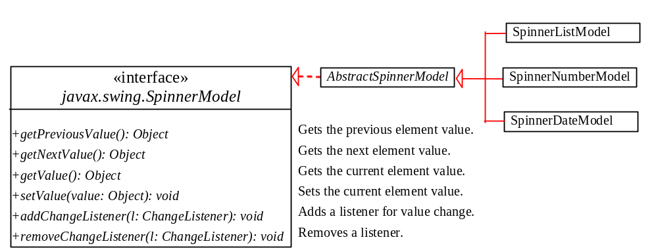

Figure 39.10
SpinnerListModel, SpinnerNumberModel, and SpinnerDateModel are concrete implementations for SpinnerModel.

39.6.1 SpinnerListModel
SpinnerListModel (see Figure 39.11) is a simple implementation of SpinnerModel whose values are stored in a java.util.List.

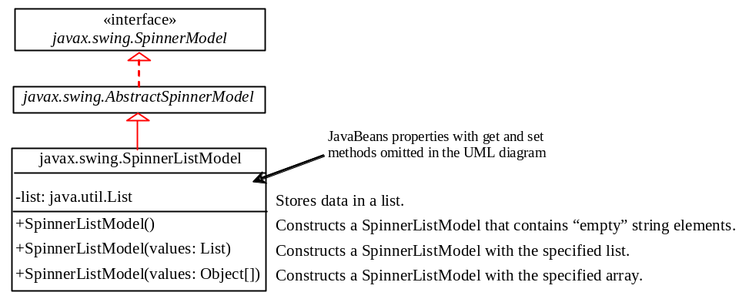

Figure 39.11
SpinnerListModel uses a java.util.List to store a sequence of data in the model.
You can create a SpinnerListModel using an array or a list. For example, the following code creates a model that consists of values Freshman, Sophomore, Junior, Senior, and Graduate in an array.

// Create an array

String[] grades = {"Freshman", "Sophomore", "Junior",

"Senior", "Graduate"};

// Create a model from an array
model = new SpinnerListModel(grades);

Alternatively, the following code creates a model using a list:

// Create an array

String[] grades = {"Freshman", "Sophomore", "Junior",

"Senior", "Graduate"};

// Create an ArrayList from the array
list = new ArrayList(Arrays.asList(grades));

// Create a model from the list
model = new SpinnerListModel(list);

The alternative code seems unnecessary. However, it is useful if you need to add or remove elements from the model. The size of the array is fixed once the array is created. The list is a flexible data structure that enables you to add or remove elements dynamically.

39.6.2 SpinnerNumberModel
SpinnerNumberModel (see Figure 39.12) is a concrete implementation of SpinnerModel that represents a sequence of numbers. It contains the properties maximum, minimum, and stepSize. The maximum and minimum properties specify the upper and lower bounds of the sequence. The stepSize specifies the size of the increase or decrease computed by the nextValue and previousValue methods defined in SpinnerModel. The minimum and maximum properties can be null to indicate that the sequence has no lower or upper limit. All of the properties in this class are defined as Number or Comparable, so that all Java numeric types may be accommodated.

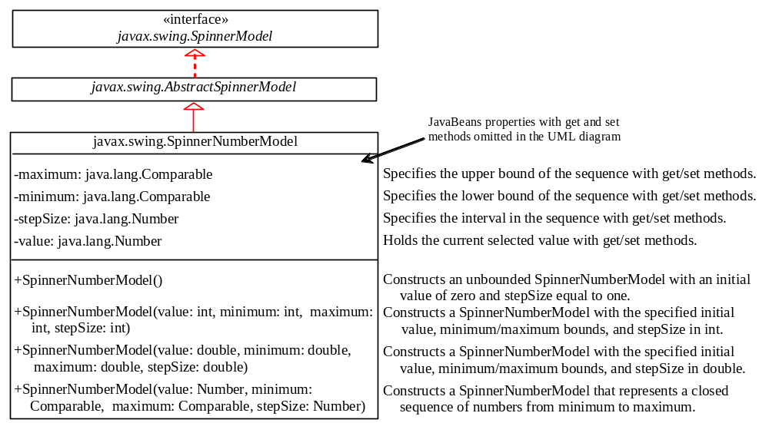

Figure 39.12
SpinnerNumberModel represents a sequence of numbers.
You can create a SpinnerNumberModel with integers or double. For example, the following code creates a model that represents a sequence of numbers from 0 to 3000 with initial value 2004 and interval 1.

// Create a spinner number model

SpinnerNumberModel model = new SpinnerNumberModel(2004, 0, 3000, 1);

The following code creates a model that represents a sequence of numbers from 0 to 120 with initial value 50 and interval 0.1.

// Create a spinner number model

SpinnerNumberModel model = new SpinnerNumberModel(50, 0, 120, 0.1);

39.6.3 SpinnerDateModel
SpinnerDateModel (see Figure 39.13) is a concrete implementation of SpinnerModel that represents a sequence of dates. The upper and lower bounds of the sequence are defined by properties called start and end, and the size of the increase or decrease computed by the nextValue and previousValue methods is defined by a property called calendarField. The start and end properties can be null to indicate that the sequence has no lower or upper limit. The value of the calendarField property must be one of the java.util.Calendar constants that specify a field within a Calendar. The getNextValue and getPreviousValue methods change the date forward or backward by this amount. For example, if calendarField is Calendar.DAY_OF_WEEK, then nextValue produces a date that is 24 hours after the current value, and previousValue produces a date that is 24 hours earlier.

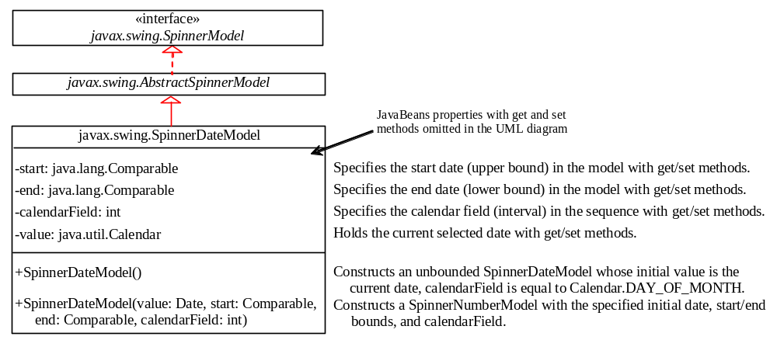

Figure 39.13
SpinnerDateModel represents a sequence of dates.
For example, the following code creates a spinner model that represents a sequence of dates, starting from the current date without a lower/upper limit and with calendar field on month.

SpinnerDateModel model = new SpinnerDateModel(
new Date(), null, null, Calendar.MONTH);

39.6.4 Spinner Editors
A JSpinner has a single child component, called the editor, which is responsible for displaying the current element or value of the model. Four editors are defined as static inner classes inside JSpinner.

- JSpinner.DefaultEditor is a simple base class for all other specialized editors to display a read-only view of the model's current value with a JFormattedTextField. JFormattedTextField extends JTextField, adding support for formatting arbitrary values, as well as retrieving a particular object once the user has edited the text.
- JSpinner.NumberEditor is a specialized editor for a JSpinner whose model is a SpinnerNumberModel. The value of the editor is displayed with a JFormattedTextField whose format is defined by a NumberFormatter instance.
- JSpinner.DateEditor is a specialized editor for a JSpinner whose model is a SpinnerDateModel. The value of the editor is displayed with a JFormattedTextField whose format is defined by a DateFormatter instance.
- JSpinner.ListEditor is a specialized editor for a JSpinner whose model is a SpinnerListModel. The value of the editor is displayed with a JFormattedTextField.

The JSpinner's constructor creates a NumberEditor for SpinnerNumberModel, a DateEditor for SpinnerDateModel, a ListEditor for SpinnerListModel, and a DefaultEditor for all other models. The editor can also be changed using the setEditor method. The JSpinner's editor stays in sync with the model by listening for ChangeEvents. The commitEdit() method should be used to commit the currently edited value to the model.

39.6.5 Example: Using Spinner Models and Editors
This example uses a JSpinner component to display the date and three other JSpinner components to display the day in a sequence of numbers, the month in a sequence of strings, and the year in a sequence of numbers, as shown in Figure 39.14. All four components are synchronized. For example, if you change the year in the spinner for year, the date value in the date spinner is updated accordingly. The source code of the example is given in Listing 39.6.

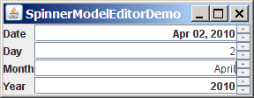

Figure 39.14
The four spinner components are synchronized to display the date in one field and the day, month, and year in three separate fields.

Listing 39.6 SpinnerModelEditorDemo.java
<margin note line 9: spinners>
<margin note line 20: create UI>
<margin note line 41: date editor>
<margin note line 46: number editor>
<margin note line 54: spinner listener>
<margin note line 62: spinner listener>
<margin note line 70: spinner listener>
<margin note line 109: main method omitted>

1 import javax.swing.*;
2 import javax.swing.event.*;
3 import java.util.*;
4 import java.text.*;
5 import java.awt.*;
6
7 public class SpinnerModelEditorDemo extends JApplet {
8 // Create four spinners for date, day, month, and year
9 private JSpinner jspDate =
10 new JSpinner(new SpinnerDateModel());
11 private JSpinner jspDay =
12 new JSpinner(new SpinnerNumberModel(1, 1, 31, 1));
13 private String[] monthNames = new DateFormatSymbols().getMonths();
14 private JSpinner jspMonth = new JSpinner
15 (new SpinnerListModel(Arrays.asList(monthNames).subList(0, 12)));
16 private JSpinner spinnerYear =
17 new JSpinner(new SpinnerNumberModel(2004, 1, 3000, 1));
18
19 public SpinnerModelEditorDemo() {
20 // Group labels
21 JPanel panel1 = new JPanel();
22 panel1.setLayout(new GridLayout(4, 1));
23 panel1.add(new JLabel("Date"));
24 panel1.add(new JLabel("Day"));
25 panel1.add(new JLabel("Month"));
26 panel1.add(new JLabel("Year"));
27
28 // Group spinners
29 JPanel panel2 = new JPanel();
30 panel2.setLayout(new GridLayout(4, 1));
31 panel2.add(jspDate);
32 panel2.add(jspDay);
33 panel2.add(jspMonth);
34 panel2.add(spinnerYear);
35
36 // Add spinner and label to the UI
37 add(panel1, BorderLayout.WEST);
38 add(panel2, BorderLayout.CENTER);
39
40 // Set editor for date
41 JSpinner.DateEditor dateEditor =
42 new JSpinner.DateEditor(jspDate, "MMM dd, yyyy");
43 jspDate.setEditor(dateEditor);
44
45 // Set editor for year
46 JSpinner.NumberEditor yearEditor =
47 new JSpinner.NumberEditor(spinnerYear, "####");
48 spinnerYear.setEditor(yearEditor);
49
50 // Update date to synchronize with the day, month, and year
51 updateDate();
52
53 // Register and create a listener for jspDay
54 jspDay.addChangeListener(new ChangeListener() {
55 @Override
56 public void stateChanged(javax.swing.event.ChangeEvent e) {
57 updateDate();
58 }
59 });
60
61 // Register and create a listener for jspMonth
62 jspMonth.addChangeListener(new ChangeListener() {
63 @Override
64 public void stateChanged(javax.swing.event.ChangeEvent e) {
65 updateDate();
66 }
67 });
68
69 // Register and create a listener for spinnerYear
70 spinnerYear.addChangeListener(new ChangeListener() {
71 @Override
72 public void stateChanged(javax.swing.event.ChangeEvent e) {
73 updateDate();
74 }
75 });
76 }
77
78 /** Update date spinner to synchronize with the other spinners */
79 private void updateDate() {
80 // Get current month and year in int
81 int month = ((SpinnerListModel)jspMonth.getModel()).
82 getList().indexOf(jspMonth.getValue());
83 int year = ((Integer)spinnerYear.getValue()).intValue();
84
85 // Set a new maximum number of days for the new month and year
86 SpinnerNumberModel numberModel =
87 (SpinnerNumberModel)jspDay.getModel();
88 numberModel.setMaximum(new Integer(maxDaysInMonth(year, month)));
89
90 // Set a new current day if it exceeds the maximum
91 if (((Integer)(numberModel.getValue())).intValue() >
92 maxDaysInMonth(year, month))
93 numberModel.setValue(new Integer(maxDaysInMonth(year, month)));
94
95 // Get the current day
96 int day = ((Integer)jspDay.getValue()).intValue();
97
98 // Set a new date in the date spinner
99 jspDate.setValue(
100 new GregorianCalendar(year, month, day).getTime());
101 }
102
103 /** Return the maximum number of days in a month. For example,
104 Feb 2004 has 29 days. */
105 private int maxDaysInMonth(int year, int month) {
106 Calendar calendar = new GregorianCalendar(year, month, 1);
107 return calendar.getActualMaximum(Calendar.DAY_OF_MONTH);
108 }
109 }

A JSpinner object for dates, jspDate, is created with a default SpinnerDateModel (lines 9-10). The format of the date displayed in the spinner is MMM dd, yyyy (e.g., Feb 01, 2006). This format is created using the JSpinner’s inner class constructor DateEditor (lines 41-42) and is set as jspDate’s editor (line 43).

A JSpinner object for days, jspDay, is created with a SpinnerNumberModel with a sequence of integers between 1 and 31 in which the initial value is 1 and the interval is 1 (lines 11-12). The maximum number is reset in the updateDate() method based on the current month and year (lines 91-93). For example, February 2004 has 29 days, so the maximum in jspDay is set to 29 for February 2004.

A JSpinner object for months, jspMonth, is created with a SpinnerListModel with a list of month names (lines 14-15). Month names are locale specific and can be obtained using the new DateFormatSymbols().getMonths() (line 13). Some calendars can have 13 months. Arrays.asList(monthNames) creates a list from an array of strings, and subList(0, 12) returns the first 12 elements in the list.

A JSpinner object for years, spinnerYear, is created with a SpinnerNumberModel with a sequence of integers between 1 and 3000 in which the initial value is 2004 and the interval is 1 (lines 16-17). By default, locale-specific number separators are used. For example, 2004 would be displayed as 2,004 in the spinner. To display the number without separators, the number pattern #### is specified to construct a new NumberEditor for spinnerYear (lines 46-47). The editor is set as spinnerYear’s editor (line 48).

The updateDate() method synchronizes the date spinner with the day, month, and year spinners. Whenever a new value is selected in the day, month, or year spinner, a new date is set in the date spinner. The maxDaysInMonth method (lines 105-108) returns the maximum number of days in a month. For example, February 2004 has 29 days.

A JSpinner object can fire javax.swing.event.ChangeEvent to notify the listeners of the state change in the spinner. The anonymous event adapters are created to process spinner state changes for the day, month, and year spinners (lines 54-75). Whenever a new value is selected in one of these three spinners, the date spinner value is updated accordingly. In Exercise 39.3, you will improve the example to synchronize the day, month, and year spinners with the date spinner. Then, when a new value is selected in the date spinner, the values in the day, month, and year spinners will be updated accordingly.

This example uses SpinnerNumberModel, SpinnerDateModel, and SpinnerListModel. They are predefined concrete spinner models in the API. You can also create custom spinner models (see Exercise 39.4).

39.7 JList and its Models
The basic features of JList were introduced in §17.9, “Lists,” without using list models. You learned how to create a list and how to respond to list selections. However, you cannot add or remove elements from a list without using list models. This section introduces list models and gives a detailed discussion on how to use JList.

JList has two supporting models: a list model and a list-selection model. The list model is for storing and processing data. The list-selection model is for selecting items. By default, items are rendered as strings or icons. You can also define a custom renderer that implements the ListCellRenderer interface. The relationship of these interfaces and classes is shown in Figure 39.15.

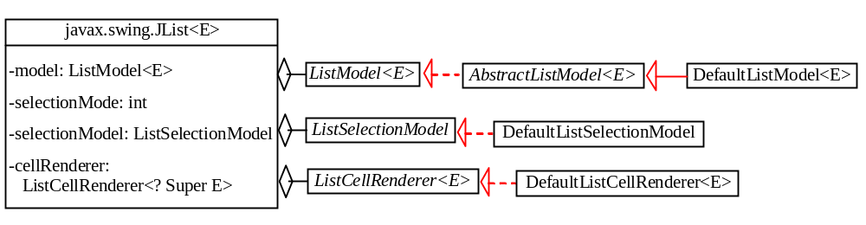

Figure 39.15
JList contains several supporting interfaces and classes.

NOTE
<margin note: JDK 7 new features>
Since JDK 7, JList, ListModel, AbstractListModel, DefaultListModel, ListCellRenderer, and DefaultListCellRenderer have been redefined as generic classes and interfaces. The generic type E represents the element type stored in the list.

39.7.1 JList Constructors, Properties, and Methods
Figure 39.16 shows the properties and constructors of JList. You can create a list from a list model, an array of objects, or a vector.

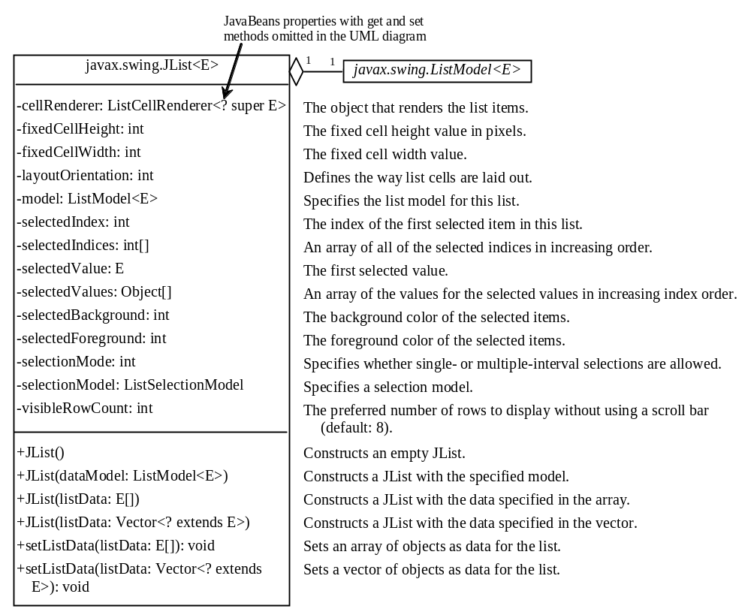

Figure 39.16
JList displays elements in a list.
39.7.2 List Layout Orientations
The layoutOrientation property specifies the layout of the items using one of the following three values:
JList.VERTICAL specifies that the cells should be laid out vertically in one column. This is the default value.

JList.HORIZONTAL_WRAP specifies that the cells should be laid out horizontally, wrapping to a new row as necessary. The number of rows to use is determined by the visibleRowCount property if its value is greater than 0; otherwise the number of rows is determined by the width of the JList.

JList.VERTICAL_WRAP specifies that the cells should be laid out vertically, wrapping to a new column as necessary. The number of rows to use is determined by the visibleRowCount property if its value is greater than 0; otherwise the number of rows is determined by the height of the JList.

For example, suppose there are five elements (item1, item2, item3, item4, and item5) in the list and the visibleRowCount is 2. Figure 39.17 shows the layout in these three cases.

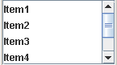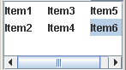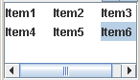

(a) Vertical (b) Vertical wrap (c) Horizontal wrap

Figure 39.17
Layout orientation specifies how elements are laid out in a list.

39.7.3 List-Selection Modes and List-Selection Models
The selectionMode property is one of the three values (SINGLE_SELECTION, SINGLE_INTERVAL_SELECTION, MULTIPLE_INTERVAL_SELECTION) that indicate whether a single item, single-interval item, or multiple-interval item can be selected, as shown in Figure 39.18. Single selection allows only one item to be selected. Single-interval selection allows multiple selections, but the selected items must be contiguous. These items can be selected all together by holding down the SHIFT key. Multiple-interval selection allows selections of multiple contiguous items without restrictions. These items can be selected by holding down the Ctrl key. The default value is MULTIPLE_INTERVAL_SELECTION.

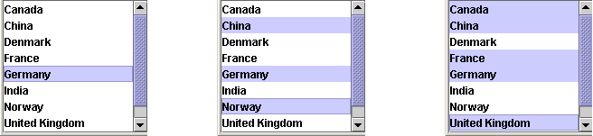
(a) Single-selection (b) Single-interval selection (c) Multiple-interval selection

Figure 39.18
A list has three selection modes.
The selectionModel property specifies an object that tracks list selection. JList has two models: a list model and a list-selection model. List models handle data management, and list-selection models deal with data selection. A list-selection model must implement the ListSelectionModel interface, which defines constants for three selection modes (SINGLE_SELECTION, SINGLE_INTERVAL_SELECTION, and MULTIPLE_INTERVAL_SELECTION), and registration methods for ListSectionListener. It also defines the methods for adding and removing selection intervals, and the access methods for the properties, such as selectionMode, anchorSelectionIndex, leadSelectionIndex, and valueIsAdjusting.

By default, an instance of JList uses DefaultListSelectionModel, which is a concrete implementation of ListSelectionModel. Usually, you do not need to provide a custom list-selection model, because the DefaultListSelectionModel class is sufficient in most cases. List-selection models are rarely used explicitly, because you can set the selection mode directly in JList.

39.7.4 Example: List Properties Demo
This example creates a list of a fixed number of items displayed as strings. The example enables you to dynamically set visibleRowCount from a spinner, layoutOrientation from a combo box, and selectionMode from a combo box, as shown in Figure 39.19. When you select one or more items, their values are displayed in a status label below the list. The source code of the example is given in Listing 39.7.

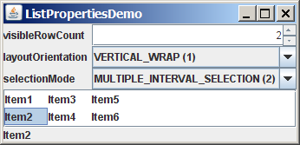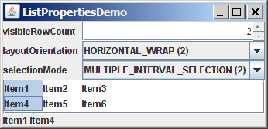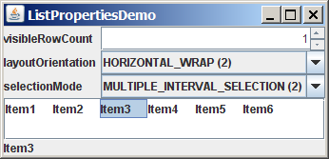

Figure 39.19
You can dynamically set the properties for visibleRowCount, layoutOrientation, and selectionMode in a list.

Listing 39.7 ListPropertiesDemo.java
<margin note line 7: list>
<margin note line 9: spinner>
<margin note line 11: combo box>
<margin note line 14: combo box>
<margin note line 22: create UI>
<margin note line 53: spinner listener>
<margin note line 61: combo box listener>
<margin note line 69: combo box listener>
<margin note line 77: list listener>
<margin note line 91: main method omitted>

1 import java.awt.*;
2 import java.awt.event.*;
3 import javax.swing.*;
4 import javax.swing.event.*;
5
6 public class ListPropertiesDemo extends JApplet {
7 private JList<String> jlst = new JList<String>(new String[] {
8 "Item1", "Item2", "Item3", "Item4", "Item5", "Item6"});
9 private JSpinner jspVisibleRowCount =
10 new JSpinner(new SpinnerNumberModel(8, -1, 20, 1));
11 private JComboBox jcboLayoutOrientation =
12 new JComboBox(new String[] {"VERTICAL (0)",
13 "VERTICAL_WRAP (1)", "HORIZONTAL_WRAP (2)"});
14 private JComboBox jcboSelectionMode =
15 new JComboBox(new String[] {"SINGLE_SELECTION (0)",
16 "SINGLE_INTERVAL_SELECTION (1)",
17 "MULTIPLE_INTERVAL_SELECTION (2)"});
18 private JLabel jlblStatus = new JLabel();
19
20 /** Construct the applet */
21 public ListPropertiesDemo() {
22 // Place labels in a panel
23 JPanel panel1 = new JPanel();
24 panel1.setLayout(new GridLayout(3, 1));
25 panel1.add(new JLabel("visibleRowCount"));
26 panel1.add(new JLabel("layoutOrientation"));
27 panel1.add(new JLabel("selectionMode"));
28
29 // Place text fields in a panel
30 JPanel panel2 = new JPanel();
31 panel2.setLayout(new GridLayout(3, 1));
32 panel2.add(jspVisibleRowCount);
33 panel2.add(jcboLayoutOrientation);
34 panel2.add(jcboSelectionMode);
35
36 // Place panel1 and panel2
37 JPanel panel3 = new JPanel();
38 panel3.setLayout(new BorderLayout(5, 5));
39 panel3.add(panel1, BorderLayout.WEST);
40 panel3.add(panel2, BorderLayout.CENTER);
41
42 // Place elements in the applet
43 add(panel3, BorderLayout.NORTH);
44 add(new JScrollPane(jlst), BorderLayout.CENTER);
45 add(jlblStatus, BorderLayout.SOUTH);
46
47 // Set initial property values
48 jlst.setFixedCellWidth(50);
49 jlst.setFixedCellHeight(20);
50 jlst.setSelectionMode(ListSelectionModel.SINGLE_SELECTION);
51
52 // Register listeners
53 jspVisibleRowCount.addChangeListener(new ChangeListener() {
54 @Override
55 public void stateChanged(ChangeEvent e) {
56 jlst.setVisibleRowCount(
57 ((Integer)jspVisibleRowCount.getValue()).intValue());
58 }
59 });
60
61 jcboLayoutOrientation.addActionListener(new ActionListener() {
62 @Override
63 public void actionPerformed(ActionEvent e) {
64 jlst.setLayoutOrientation(
65 jcboLayoutOrientation.getSelectedIndex());
66 }
67 });
68
69 jcboSelectionMode.addActionListener(new ActionListener() {
70 @Override
71 public void actionPerformed(ActionEvent e) {
72 jlst.setSelectionMode(
73 jcboSelectionMode.getSelectedIndex());
74 }
75 });
76
77 jlst.addListSelectionListener(new ListSelectionListener() {
78 @Override
79 public void valueChanged(ListSelectionEvent e) {
80 Object[] values = jlst.getSelectedValues();
81 String display = "";
82
83 for (int i = 0; i < values.length; i++) {
84 display += (String)values[i] + " ";
85 }
86
87 jlblStatus.setText(display);
88 }
89 });
90 }
91 }

A JList is created with six string values (lines 7-8). A JSpinner is created using a SpinnerNumberModel with initial value 8, minimum value –1, maximum value 20, and step 1 (lines 9-10). A JComboBox is created with string values VERTICAL (0), VERTICAL_WRAP (1), and HORIZONTAL_WRAP (2) for choosing layout orientation (lines 11-13). A JComboBox is created with string values SINGLE_SELECTION (0), INTERVAL_SELECTION (1), and MULTIPLE_INTERVAL_SELECTION (2) for choosing a selection mode (lines 14-17). A JLabel is created to display the selected elements in the list (lines 18).

A JList does not support scrolling. To create a scrollable list, create a JScrollPane and add an instance of JList to it (line 44).

The fixed list cell width and height are specified in lines 48-49. The default selection mode is multiple-interval selection. Line 50 sets the selection mode to single selection.

When a new visible row count is selected from the spinner, the setVisibleRowCount method is used to set the count (lines 53-58). When a new layout orientation is selected from the jcboLayoutOrientation combo box, the setLayoutOrientation method is used to set the layout orientation (lines 60-65). Note that the constant values for VERTICAL, VERTICAL_WRAP, and HORIZONTAL_WRAP are 0, 1, and 2, which correspond to the index values of these items in the combo box. When a new selection mode is selected from the jcboSelectionMode combo box, the setSelectionMode method is used to set the selection mode (lines 67-72). Note that the constant values for SINGLE_SELECTION, SINGLE_INTERVAL_SELECTION, and MULTIPLE_INTERVAL_SELECTION are 0, 1, and 2, which correspond to the index value of these items in the combo box.

JList fires javax.swing.event.ListSelectionEvent to notify the listeners of the selections. The listener must implement the valueChanged handler to process the event. When the user selects an item in the list, the valueChanged handler is executed, which gets the selected items and displays all the items in the label (lines 74-85).

39.8 List Models
The preceding example constructs a list with a fixed set of strings. If you want to add new items to the list or delete existing items, you have to use a list model. This section introduces list models.

The JList class delegates the responsibilities of storing and maintaining data to its data model. The JList class itself does not have methods for adding or removing items from the list. These methods are supported in ListModel, as shown in Figure 39.20.

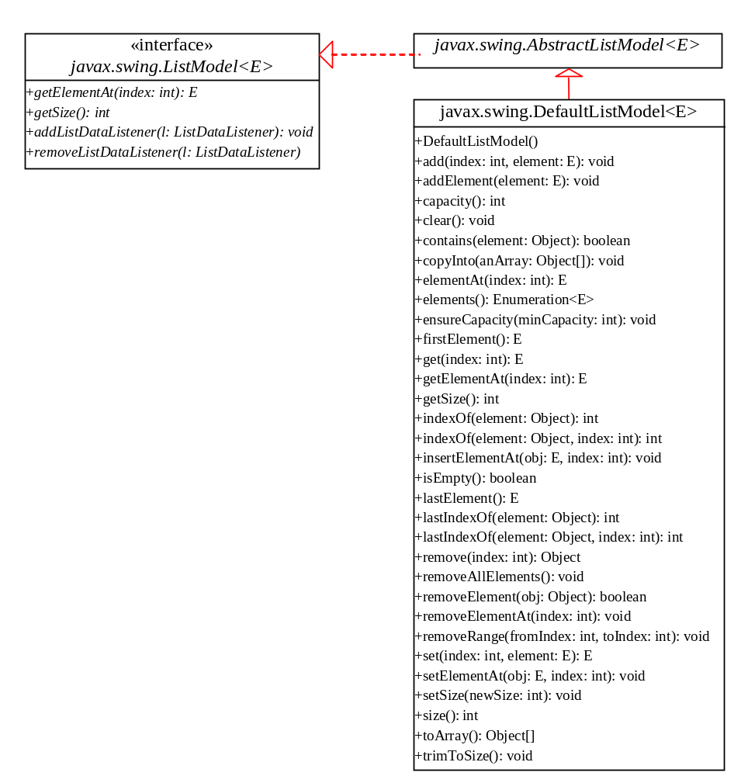

Figure 39.20
ListModel stores and manages data in a list.
All list models implement the ListModel interface, which defines the registration methods for ListDataEvent. The instances of ListDataListener are notified when the items in the list are modified. ListModel also defines the methods getSize and getElementAt. The getSize method returns the length of the list, and the getElementAt method returns the element at the specified index.

AbstractListModel implements the ListModel and Serializable interfaces. AbstractListModel implements the registration methods in the ListModel, but does not implement the getSize and getElementAt methods.

DefaultListModel extends AbstractListModel and implements the two methods getSize and getElementAt, which are not implemented by AbstractListModel.

The methods in DefaultListModel are similar to those in the java.util.Vector class. You use the add method to insert an element to the list, the remove method to remove an element from the list, the clear method to clear the list, the getSize method to return the number of elements in the list, and the getElementAt method to retrieve an element. In fact, the DefaultListModel stores data in an instance of Vector, which is essentially a resizable array. Swing components were developed before the Java Collections Framework. In future implementations, Vector may be replaced by java.util.ArrayList.

NOTE
<margin note: default list model>
In most cases, if you create a Swing GUI object without specifying a model, an instance of the default model class is created. But this is not true for JList. By default, the model property in JList is not an instance of DefaultListModel. To use a list model, you should explicitly create one using DefaultListModel.
Listing 39.8 gives an example that creates a list using a list model and allows the user to add and delete items in the list, as shown in Figure 39.21. When the user clicks the Add new item button, an input dialog box is displayed to receive a new item.

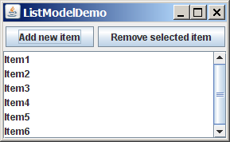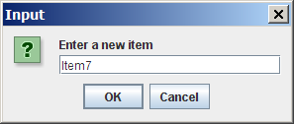

Figure 39.21
You can add elements and remove elements in a list using list models.

Listing 39.8 ListModelDemo.java
<margin note line 6: list model>
<margin note line 8: list>
<margin note line 15: add items>
<margin note line 30: button listener>
<margin note line 44: button listener>
<margin note line 51: main method omitted>

1 import java.awt.*;
2 import java.awt.event.*;
3 import javax.swing.*;
4
5 public class ListModelDemo extends JApplet {
6 private DefaultListModel<String> listModel
7 = new DefaultListModel<String>();
8 private JList<String> jlst = new JList<String>(listModel);
9 private JButton jbtAdd = new JButton("Add new item");
10 private JButton jbtRemove = new JButton("Remove selected item");
11
12 /** Construct the applet */
13 public ListModelDemo() {
14 // Add items to the list model
15 listModel.addElement("Item1");
16 listModel.addElement("Item2");
17 listModel.addElement("Item3");
18 listModel.addElement("Item4");
19 listModel.addElement("Item5");
20 listModel.addElement("Item6");
21
22 JPanel panel = new JPanel();
23 panel.add(jbtAdd);
24 panel.add(jbtRemove);
25
26 add(panel, BorderLayout.NORTH);
27 add(new JScrollPane(jlst), BorderLayout.CENTER);
28
29 // Register listeners
30 jbtAdd.addActionListener(new ActionListener() {
31 @Override
32 public void actionPerformed(ActionEvent e) {
33 String newItem =
34 JOptionPane.showInputDialog("Enter a new item");
35
36 if (newItem != null)
37 if (jlst.getSelectedIndex() == -1)
38 listModel.addElement(newItem);
39 else
40 listModel.add(jlst.getSelectedIndex(), newItem);
41 }
42 });
43
44 jbtRemove.addActionListener(new ActionListener() {
45 @Override
46 public void actionPerformed(ActionEvent e) {
47 listModel.remove(jlst.getSelectedIndex());
48 }
49 });
50 }
51 }

The program creates listModel (line 6), which is an instance of DefaultListModel, and uses it to manipulate data in the list. The model enables you to add and remove items in the list.

A list is created from the list model (line 7). The initial elements are added into the model using the addElement method (lines 13-19).

To add an element, the user clicks the Add new item button to display an input dialog box. Type a new item in the dialog box. The new item is inserted before the currently selected element in the list (line 38). If no element is selected, the new element is appended to the list (line 36).

To remove an element, the user has to select the element and then click the Remove selected item button. Note that only the first selected item is removed. You can modify the program to remove all the selected items (see Exercise 39.6).

What would happen if you clicked the Remove selected item button but no items were currently selected? This would cause an error. To fix it, see Exercise 39.6.

39.9 List Cell Renderer
The preceding example displays items as strings in a list. JList is very flexible and versatile, and it can be used to display images and GUI components in addition to simple text. This section introduces list cell renderers for displaying graphics.

In addition to delegating data storage and processing to list models, JList delegates the rendering of list cells to list cell renderers. All list cell renderers implement the ListCellRenderer interface, which defines a single method, getListCellRendererComponent, as follows:

public Component getListCellRendererComponent
(JList list, Object value, int index, boolean isSelected,
boolean cellHasFocus)
This method is passed with a list, the value associated with the cell, the index of the value, and information regarding whether the value is selected and whether the cell has the focus. The component returned from the method is painted on the cell in the list. By default, JList uses DefaultListCellRenderer to render its cells. The DefaultListCellRenderer class implements ListCellRenderer, extends JLabel, and can display either a string or an icon, but not both in the same cell.

For example, you can use JList’s default cell renderer to display strings, as shown in Figure 39.22(a), using the following code:

JList list = new JList(new String[]{"Denmark", "Germany",

"China", "India", "Norway", "UK", "US"});

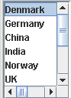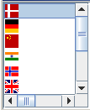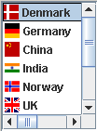

(a) Strings (b) Icons (c) Icons and strings

Figure 39.22
The cell renderer displays list items in a list.
You can use JList’s default cell renderer to display icons, as shown in Figure 39.22(b), using the following code:

ImageIcon denmarkIcon = new ImageIcon(getClass().getResource(
"image/denmarkIcon.gif"));
...

JList list = new JList(new ImageIcon[]{denmarkIcon, germanyIcon,
chinaIcon, indiaIcon, norwayIcon, ukIcon, usIcon});

How do you display a string along with an icon in one cell, as shown in Figure 39.22(c)? You need to create a custom renderer by implementing ListCellRenderer, as shown in Figure 39.23.

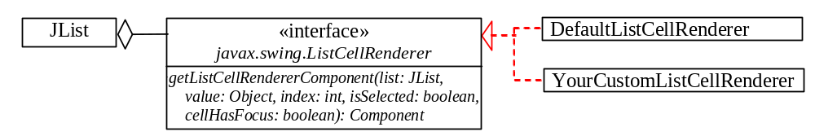

Figure 39.23
ListCellRenderer defines how cells are rendered in a list.
Suppose a list is created as follows:

JList list = new JList(new Object[][]{{denmarkIcon, "Denmark"},
{germanyIcon, "Germany"}, {chinaIcon, "China"},
{indiaIcon, "India"}, {norwayIcon, "Norway"}, {ukIcon, "UK"},
{usIcon, "US"}});

Each item in the list is an array that consists of an icon and a string. You can create a custom cell renderer that retrieves an icon and a string from the list data model and display them in a label. The custom cell renderer class is given in Listing 39.9.

Listing 39.9 MyListCellRenderer.java
<margin note line 6: cell component>
<margin note line 18: set icon>
<margin note line 19: set text>
<margin note line 22: cell selected>
<margin note line 32: return rendering cell>

1 import java.awt.*;
2 import javax.swing.*;
3 import javax.swing.border.*;
4
5 public class MyListCellRenderer implements ListCellRenderer {
6 private JLabel jlblCell = new JLabel(" ", JLabel.LEFT);
7 private Border lineBorder =
8 BorderFactory.createLineBorder(Color.black, 1);
9 private Border emptyBorder =
10 BorderFactory.createEmptyBorder(2, 2, 2, 2);
11
12 /** Implement this method in ListCellRenderer */
13 public Component getListCellRendererComponent
14 (JList list, Object value, int index, boolean isSelected,
15 boolean cellHasFocus) {
16 Object[] pair = (Object[])value; // Cast value into an array
17 jlblCell.setOpaque(true);
18 jlblCell.setIcon((ImageIcon)pair[0]);
19 jlblCell.setText(pair[1].toString());
20
21 if (isSelected) {
22 jlblCell.setForeground(list.getSelectionForeground());
23 jlblCell.setBackground(list.getSelectionBackground());
24 }
25 else {
26 jlblCell.setForeground(list.getForeground());
27 jlblCell.setBackground(list.getBackground());
28 }
29
30 jlblCell.setBorder(cellHasFocus ? lineBorder : emptyBorder);
31
32 return jlblCell;
33 }
34 }

The MyListCellRenderer class implements the getListCellRendererComponent method in the ListCellRenderer interface. This method is passed with the parameters list, value, index, isSelected, and isFocused (lines 13-15). The value represents the current item value. In this case, it is an array consisting of two elements. The first element is an image icon (line 18). The second element is a string (line 19). Both image icon and string are displayed on a label. The getListCellRendererComponent method returns the label (line 32), which is painted on the cell in the list.

If the cell is selected, the background and foreground of the cell are set to the list's selection background and foreground (lines 22-23). If the cell is focused, the cell's border is set to the line border (line 30); otherwise, it is set to the empty border (line 30). The empty border serves as a divider between the cells.

NOTE
<margin note: any GUI renderer>
The example in Listing 39.9 uses a JLabel as a renderer. You may use any GUI component as a renderer, returned from the getListCellRendererComponent method.
Let us develop an example (Listing 39.10) that creates a list of countries and displays the flag image and name for each country as one item in the list, as shown in Figure 39.24. When a country is selected in the list, its flag is displayed in a label next to the list.

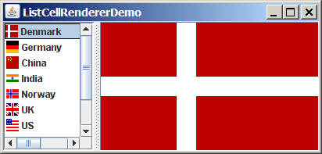
Small icon
Large icon

Figure 39.24
The image and the text are displayed in the list cell.

Listing 39.10 ListCellRendererDemo.java
<margin note line 7: nation strings>
<margin note line 9: small icons>
<margin note line 10: big icons>
<margin note line 13: list model>
<margin note line 16: list>
<margin note line 19: list cell renderer>
<margin note line 22: split pane>
<margin note line 25: image label>
<margin note line 31: load image icons>
<margin note line 33: add elements>
<margin note line 35: load image icons>
<margin note line 40: set renderer>
<margin note line 49: list listener>
<margin note line 55: main method omitted>

1 import javax.swing.*;
2 import javax.swing.event.*;
3 import java.awt.*;
4
5 public class ListCellRendererDemo extends JApplet {
6 private final static int NUMBER_OF_NATIONS = 7;
7 private String[] nations = new String[]
8 {"Denmark", "Germany", "China", "India", "Norway", "UK", "US"};
9 private ImageIcon[] icons = new ImageIcon[NUMBER_OF_NATIONS];
10 private ImageIcon[] bigIcons = new ImageIcon[NUMBER_OF_NATIONS];
11
12 // Create a list model
13 private DefaultListModel listModel = new DefaultListModel();
14
15 // Create a list using the list model
16 private JList jlstNations = new JList(listModel);
17
18 // Create a list cell renderer
19 private ListCellRenderer renderer = new MyListCellRenderer();
20
21 // Create a split pane
22 private JSplitPane jSplitPane1 = new JSplitPane();
23
24 // Create a label for displaying iamge
25 private JLabel jlblImage = new JLabel("", JLabel.CENTER);
26
27 /** Construct ListCellRenderer */
28 public ListCellRendererDemo() {
29 // Load small and large image icons
30 for (int i = 0; i < NUMBER_OF_NATIONS; i++) {
31 icons[i] = new ImageIcon(getClass().getResource(
32 "/image/flagIcon" + i + ".gif"));
33 listModel.addElement(new Object[]{icons[i], nations[i]});
34
35 bigIcons[i] = new ImageIcon(getClass().getResource(
36 "/image/flag" + i + ".gif"));
37 }
38
39 // Set list cell renderer
40 jlstNations.setCellRenderer(renderer);
41 jlstNations.setPreferredSize(new Dimension(200, 200));
42 jSplitPane1.setLeftComponent(new JScrollPane(jlstNations));
43 jSplitPane1.setRightComponent(jlblImage);
44 jlstNations.setSelectedIndex(0);
45 jlblImage.setIcon(bigIcons[0]);
46 add(jSplitPane1, BorderLayout.CENTER);
47
48 // Register listener
49 jlstNations.addListSelectionListener(new ListSelectionListener() {
50 public void valueChanged(ListSelectionEvent e) {
51 jlblImage.setIcon(bigIcons[jlstNations.getSelectedIndex()]);
52 }
53 });
54 }
- }

Two types of icons are used in this program. The small icons are created from files flagIcon0.gif, ..., flagIcon6.gif (lines 31-32). These image files are the flags for Denmark, Germany, China, India, Norway, UK, and US. The small icons are rendered inside the list. The large icons for the same countries are created from files flag0.gif, ..., flag6.gif (lines 35-36). The large icons are displayed on a label on the right side of the split pane.

The ListCellRendererDemo class creates a list model (line 13) and adds the items to the model (line 33). Each item is an array of two elements (image icon and string). The list is created using the list model (line 16). The list cell renderer is created (line 19) and associated with the list (line 40).

The ListCellRendererDemo class creates a split pane (line 22) and places the list on the left (line 42) and a label on the right (line 43).

When you choose a country in the list, the list-selection event handler is invoked (lines 49-53) to set a new image to the label in the right side of the split pane (line 51).

39.10 JComboBox and its Models
The basic features of JComboBox were introduced in §17.8, “Combo Boxes,” without using combo box models. This section introduces combo models and discusses the use of JComboBox in some detail.

A combo box is similar to a list. Combo boxes and lists are both used for selecting items from a list. A combo box allows the user to select one item at a time, whereas a list permits multiple selections. When a combo box is selected, it displays a drop-down list contained in a popup menu. The selected item can be edited in the cell as if it were a text field. Figure 39.25 shows the properties and constructors of JComboBox. The data for a combo box are stored in ComboBoxModel. You can create a combo box from a combo box model, an array of objects, or a vector.

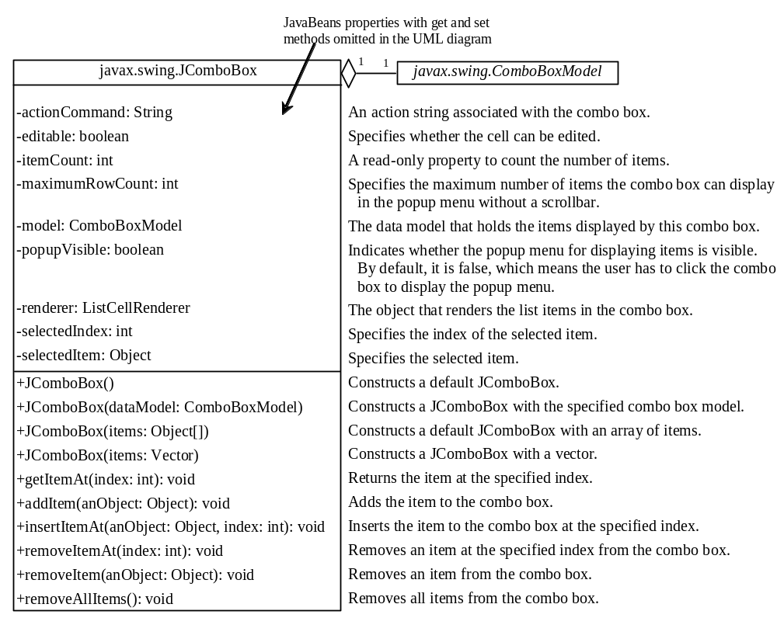

Figure 39.25
JComboBox displays elements in a list.
JComboBox delegates the responsibilities of storing and maintaining data to its data model. All combo box models implement the ComboBoxModel interface, which extends the ListModel interface and defines the getSelectedItem and setSelectedItem methods for retrieving and setting a selected item. The methods for adding and removing items are defined in the MutableComboBoxModel interface, which extends ComboBoxModel. When an instance of JComboBox is created without explicitly specifying a model, an instance of DefaultComboBoxModel is used. The DefaultComboBoxModel class extends AbstractListModel and implements MutableComboBoxModel, as shown in Figure 39.26.

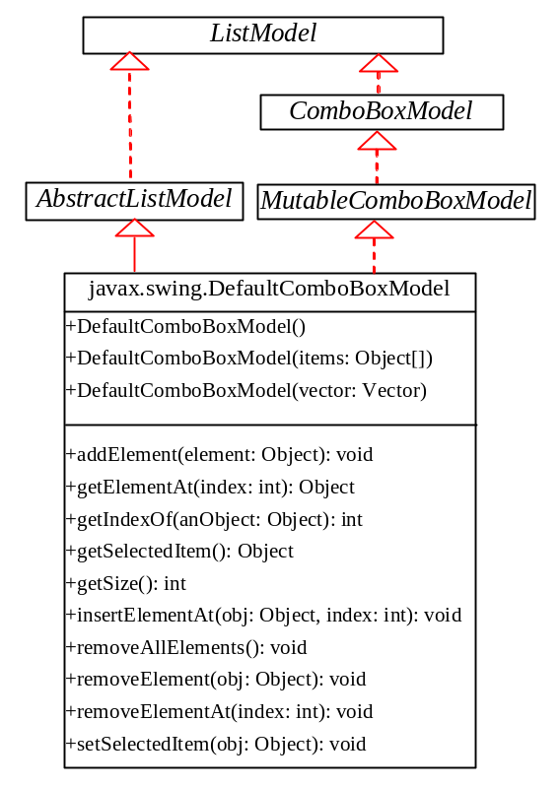

Figure 39.26
ComboBoxModel stores and manages data in a combo box.
Usually you don’t need to use combo box models explicitly, because JComboBox contains the methods for retrieving (getItemAt, getSelectedItem, and getSelectedIndex), adding (addItem and insertItemAt), and removing (removeItem, removeItemAt, and removeAllItems) items from the list.

JComboBox can fire ActionEvent and ItemEvent, among many other events. Whenever a new item is selected, JComboBox fires ItemEvent twice, once for deselecting the previously selected item, and the other for selecting the currently selected item. JComboBox fires an ActionEvent after generating an ItemEvent.

Combo boxes render cells exactly like lists, because the combo box items are displayed in a list contained in a popup menu. Therefore, a combo box cell renderer can be created exactly like a list cell renderer by implementing the ListCellRenderer interface. Like JList, JComboBox has a default cell renderer that displays a string or an icon, but not both at the same time. To display a combination of a string and an icon, you need to create a custom renderer. The custom list cell renderer MyListCellRenderer in Listing 39.9 can be used as a combo box cell renderer without any modification.

Listing 39.11 gives an example that creates a combo box to display the flag image and name for each country as one item in the list, as shown in Figure 39.27. When a country is selected in the list, its flag is displayed in a panel below the combo box.

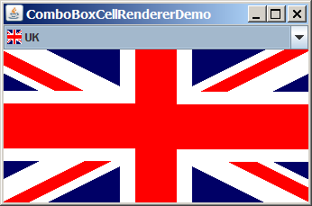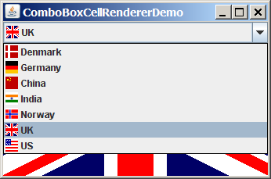

Figure 39.27
The image and the text are displayed in the list cell of a combo box.

Listing 39.11 ComboBoxCellRendererDemo.java
<margin note line 7: nation strings>
<margin note line 9: small icons>
<margin note line 10: big icons>
<margin note line 13: combo box model>
<margin note line 16: combo box>
<margin note line 19: list cell renderer>
<margin note line 22: image label>
<margin note line 28: load image icons>
<margin note line 30: add elements>
<margin note line 32: load image icons>
<margin note line 37: set renderer>
<margin note line 43: action listener>
<margin note line 50: main method omitted>

1 import java.awt.*;
2 import java.awt.event.*;
3 import javax.swing.*;
4
5 public class ComboBoxCellRendererDemo extends JApplet {
6 private final static int NUMBER_OF_NATIONS = 7;
7 private String[] nations = new String[] {"Denmark",
8 "Germany", "China", "India", "Norway", "UK", "US"};
9 private ImageIcon[] icons = new ImageIcon[NUMBER_OF_NATIONS];
10 private ImageIcon[] bigIcons = new ImageIcon[NUMBER_OF_NATIONS];
11
12 // Create a combo box model
13 private DefaultComboBoxModel model = new DefaultComboBoxModel();
14
15 // Create a combo box with the specified model
16 private JComboBox jcboCountries = new JComboBox(model);
17
18 // Create a list cell renderer
19 private MyListCellRenderer renderer = new MyListCellRenderer();
20
21 // Create a label for displaying iamge
22 private JLabel jlblImage = new JLabel("", JLabel.CENTER);
23
24 /** Construct the applet */
25 public ComboBoxCellRendererDemo() {
26 // Load small and large image icons
27 for (int i = 0; i < NUMBER_OF_NATIONS; i++) {
28 icons[i] = new ImageIcon(getClass().getResource(
29 "/image/flagIcon" + i + ".gif"));
30 model.addElement(new Object[]{icons[i], nations[i]});
31
32 bigIcons[i] = new ImageIcon(getClass().getResource(
33 "/image/flag" + i + ".gif"));
34 }
35
36 // Set list cell renderer for the combo box
37 jcboCountries.setRenderer(renderer);
38 jlblImage.setIcon(bigIcons[0]);
39 add(jcboCountries, java.awt.BorderLayout.NORTH);
40 add(jlblImage, java.awt.BorderLayout.CENTER);
41
42 // Register listener
43 jcboCountries.addActionListener(new ActionListener() {
44 @Override
45 public void actionPerformed(java.awt.event.ActionEvent e) {
46 jlblImage.setIcon(bigIcons[jcboCountries.getSelectedIndex()]);
47 }
48 });
49 }
50 }

The program is very similar to the preceding example in Listing 39.10. Two types of image icons are loaded for each country and stored in the arrays icons and bigIcons (lines 27-34). Each item in the combo box is an array that consists of an icon and a string (line 30).

MyListCellRenderer, defined in Listing 39.9, is used to create a cell renderer in line 19. The cell renderer is plugged into the combo box in line 37.

When you choose a country from the combo box, the action event handler is invoked (lines 44-46). This handler sets a new image on the label (line 45).

Key Terms

- controller
- model
- MVC architecture
- view

Chapter Summary
- The fundamental issue in the model-view approach is to ensure consistency between the views and the model. Any change in the model should be notified to the dependent views, and all the views should display the same data consistently. The model can be implemented as a source with appropriate event and event listener registration methods. The view can be implemented as a listener. Thus, if data are changed in the model, the view will be notified.

- Every Swing user interface component (e.g., JButton, JTextField, JList, and JComboBox) has a property named model that refers to its data model. The data model is defined in an interface whose name ends with Model (e.g., SpinnerModel, ListModel, ListSelectionModel, and ComboBoxModel).

- Most simple Swing components (e.g., JButton, JTextField, JTextArea) contain some properties of their models, and these properties can be accessed and modified directly from the component without the existence of the model being known.

- A JSpinner is displayed as a text field with a pair of tiny arrow buttons on its right side that enable the user to select numbers, dates, or values from an ordered sequence. A JSpinner's sequence value is defined by the SpinnerModel interface. AbstractSpinnerModel is a convenient abstract class that implements SpinnerModel and provides the implementation for its registration/deregistration methods. SpinnerListModel, SpinnerNumberModel, and SpinnerDateModel are concrete implementations of SpinnerModel. SpinnerNumberModel represents a sequence of numbers with properties maximum, minimum, and stepSize. SpinnerDateModel represents a sequence of dates. SpinnerListModel can store a list of any object values.

- A JSpinner has a single child component, called the editor, which is responsible for displaying the current element or value of the model. Four editors are defined as static inner classes inside JSpinner: JSpinner.DefaultEditor, JSpinner.NumberEditor, JSpinner.DateEditor, and JSpinner.ListEditor.

- JList has two supporting models: a list model and a list-selection model. The list model is for storing and processing data. The list-selection model is for selecting items. By default, items are rendered as strings or icons. You can also create a custom renderer implementing the ListCellRenderer interface.

- JComboBox delegates the responsibilities of storing and maintaining data to its data model. All combo box models implement the ComboBoxModel interface, which extends the ListModel interface and defines the getSelectedItem and setSelectedItem methods for retrieving and setting a selected item. The methods for adding and removing items are defined in the MutableComboBoxModel interface, which extends ComboBoxModel. When an instance of JComboBox is created without explicitly specifying a model, an instance of DefaultComboBoxModel is used. The DefaultComboBoxModel class extends AbstractListModel and implements MutableComboBoxModel.

- Combo boxes render cells exactly like lists, because the combo box items are displayed in a list contained in a popup menu. Therefore, a combo box cell renderer can be created exactly like a list cell renderer by implementing the ListCellRenderer interface.

Test Questions
Do the test questions for this chapter online at www.cs.armstrong.edu/liang/intro9e/test.html.

Review Questions

Sections 39.2-39.3
39.1
What is model-view-controller architecture?
39.2
How do you do implement models, views, and controllers?
39.3
What are the variations of MVC architecture?

Section 39.4
39.4
Does each Swing GUI component (except containers such as JPanel) have a property named model? Is the type of model the same for all the components?

39.5
Does each model interface have a default implementation class? If so, does a Swing component use the default model class if no model is specified?

Sections 39.5-39.6
39.6
If you create a JSpinner without specifying a data model, what is the default model?

39.7
What is the internal data structure for storing data in SpinnerListModel? How do you convert an array to a list?

Sections 39.7-39.9
39.8
Does JList have a method, such as addItem, for adding an item to a list? How do you add items to a list? Can JList display icons and custom GUI objects in a list? Can a list item be edited? How do you initialize data in a list? How do you specify the maximum number of visible rows in a list without scrolling? How do you specify the height of a list cell? How do you specify the horizontal margin of list cells?
39.9 How do you create a list model? How do you add items to a list model? How do you remove items from a list model?
39.10 What are the three list-selection modes? Can you set the selection modes directly in an instance of JList? How do you obtain the selected item(s)?
39.11 How do you define a custom list cell renderer?
39.12 What is the handler for handling the ListSelectionEvent?

Section 39.10
39.13 Can multiple items be selected from a combo box? Can a combo box item be edited? How do you specify the maximum number of visible rows in a combo box without scrolling? Can you specify the height of a combo box cell using a method in JComboBox? How do you obtain the selected item in a combo box?
39.14 How do you add or remove items from a combo box?
39.15 Why is the cell renderer for a combo box the same as the renderer for a list?

Programming Exercises

Section 39.2
39.1***
(Create MVC components) Create a model, named ChartModel, which holds data in an array of double elements named data, and the names for the data in an array of strings named dataName. For example, the enrollment data {200, 40, 50, 100, 40} stored in the array data are for {"CS", "Math", "Chem", "Biol", "Phys"} in the array dataName. These two properties have their respective get methods, but not individual set methods. Both properties are set together in the setChartData(String[] newDataName, double[] newData) method so that they can be displayed properly. Create a view named PieChart to present the data in a pie chart, and create a view named BarChart to present the data in a bar chart, as shown in Figure 39.28(a).

(Hint: Each pie represents a percentage of the total data. Color the pie using the colors from an array named colors, which is {Color.red, Color.yellow, Color.green, Color.blue, Color.cyan, Color.magenta, Color.orange, Color.pink, Color.darkGray}. Use colors[i % colors.length] for the ith pie. Use black color to display the data names.)

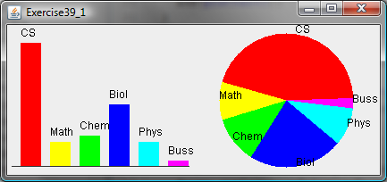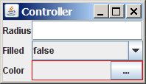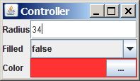
(a) (b)

Figure 39.28

(a) The two views, PieChart and BarChart, receive data from the ChartModel; (b) Clicking the eclipse button displays the color chooser dialog box for specifying a color.

39.2*
(Revise Listing 39.3 CircleController.java) CircleController uses a text field to obtain a new radius and a combo box to obtain a Boolean value to specify whether the circle is filled. Add a new row in CircleController to let the user choose color using the JColorChooser component, as shown in Figure 39.28(b). The new row consists of a label with text Color, a label to display color, and an eclipse button. The user can click the eclipse button to display a JColorChooser dialog box. Once the user selects a color, the color is displayed as the background for the label on the left of the eclipse button.

Sections 39.5-39.6
39.3**
(Synchronize spinners) The date spinner is synchronized with the day, month, and year spinners in Listing 39.6, SpinnerModelEditorDemo.java. Improve it to synchronize the day, month, and year spinners with the date spinner. In other words, when a new value is selected in the date spinner, the values in the day, month, and year spinners are updated accordingly.

39.4*
(Custom spinner model) Develop a custom spinner model that represents a sequence of numbers of power 2—that is, 1, 2, 4, 8, 16, 32, and so on. Your model should implement AbstractSpinnerModel. The registration/deregistration methods for ChangeListener have already been implemented in AbstractSpinnerModel. You need to implement getNextValue(), getPreviousValue(), getValue(), and setValue(Object) methods.

39.5*
(Reverse the numbers displayed in a spinner) The numbers displayed in a spinner increase when the up-arrow button is clicked and decrease when the down-arrow button is clicked. You can reverse the sequence by creating a new model that extends SpinnerNumberModel and overrides the getNextValue and getPreviousValue methods. Write a test program that uses the new model, as shown in Figure 39.29.

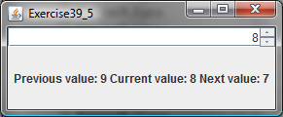

Figure 39.29

The numbers in the spinner are in decreasing order.

Sections 39.7-39.9
39.6*
(Remove selected items in a list) Modify Listing 39.8, ListModelDemo.java, to meet the following requirements:
- Remove all the selected items from the list when the Remove selected item button is clicked.
- Enable the items to be deleted using the DELETE key.

39.7*
(Custom list cell renderer) Listing 39.10, ListCellRendererDemo.java, has two types of images for each country. The small images are used for display in the list, and the large ones are used for display outside the list. Assume that only the large images are available. Rewrite the custom cell renderer to use a JPanel instead of a JLabel for rendering a cell. Each cell consists of an image and a string. Display the image in an ImageViewer and the string in a label. The ImageViewer component was introduced in Listing 13.15, ImageViewer.java. The image can be stretched in an ImageViewer. Set the dimension of an image viewer to 32 by 32, as shown in Figure 39.30. Revise Listing 39.10 to test the new custom cell renderer.
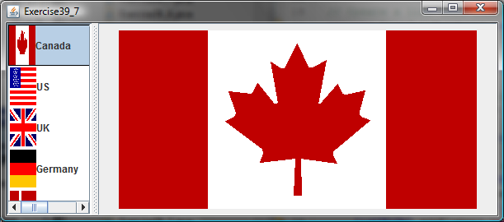
ImageViewer
JLabel
Same image as in the list

Figure 39.30

ImageViewer is used to render the image in the list.

39.8*
(Delete selected items in a list using the DELETE key) Modify Listing 39.10, ListCellRendererDemo.java, to delete selected items from the list using the DELETE key. After some items are deleted from the list, the index of a selected item in the list does not match the index of the item in the bigIcons array. As a result, you cannot use the image icon in the bigIcons array to display the image to the right side of the split pane. Revise the program to retrieve the icon from the selected item in the list and display it, as shown in Figure 39.31.

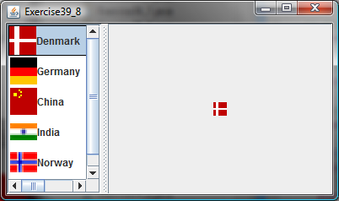
JLabel
Same image as in the list

Figure 39.31
Images in the list are also used for display in the label placed in the right side of a split pane.

39.9**
(Render figures) Create a program that shows a list of geometrical shapes along with a label in an instance of JList, as shown in Figure 39.32(a). Display the selected figure in a panel when selecting a figure from the list. The figures can be drawn using the FigurePanel class in Listing 14.5, FigurePanel.java.
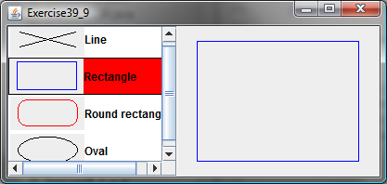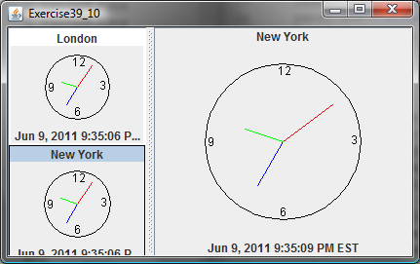
(a) (b)

Figure 39.32
(a) The list displays geometrical shapes and their names; (b) The list displays cities and clocks.

39.10**
(List of clocks) Write a program that displays a list of cities and their local times in a clock, as shown in Figure 39.32(b). When a city is selected in the list, its clock is displayed in a large picture on the right.

Section 39.10
39.11**
(Create custom cell renderer in a combo box) Create a program that shows a list of geometrical shapes along with a label in a combo box, as shown in Figure 39.33(a). This exercise may share the list cell renderer with Exercise 39.9.
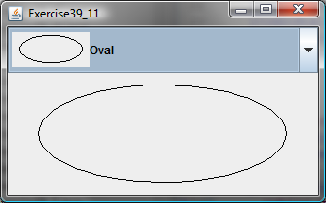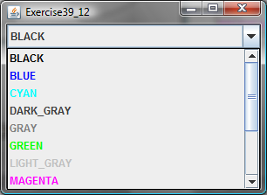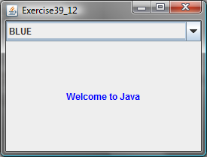
(a) (b)

Figure 39.33
(a) The combo box contains a list of geometrical shapes and the shape names. (b) The combo box contains a list of color names, each using its own color for its foreground.

39.12**
(Render colored text) Write a program that enables the user to choose the foreground colors for a label, as shown in Figure 39.33(b). The combo box contains 13 standard colors (BLACK, BLUE, CYAN, DARK_GRAY, GRAY, GREEN, LIGHT_GRAY, MAGENTA, ORANGE, PINK, RED, WHITE, YELLOW). Each color name in the combo box uses its own color for its foreground.

39.13*
(Delete a selected item in a combo box using the DELETE key) Modify Listing 39.11, ComboBoxCellRendererDemo.java, to delete the selected item from the combo box using the DELETE key.

Comprehensive

39.14*
(Calendar) Write a program that controls a calendar using a spinner, as shown in Figure 39.7. Use the CalendarPanel class (see Listing 31.4) to display the calendar.

